**DATA ANALYTICS**

**MINI PROJECT**

**Title Name:**

**Amazon Global Superstore Sales**

**Columns: 30**

**Rows: 51292**

**Project Description:**

This project showcases an Amazon Global Sales Dashboard created using Power BI. The dashboard provides a visual analysis of Amazon's sales data from different regions, markets, and customer segments between the years 2012 to 2015.

**Removing Duplicates:**

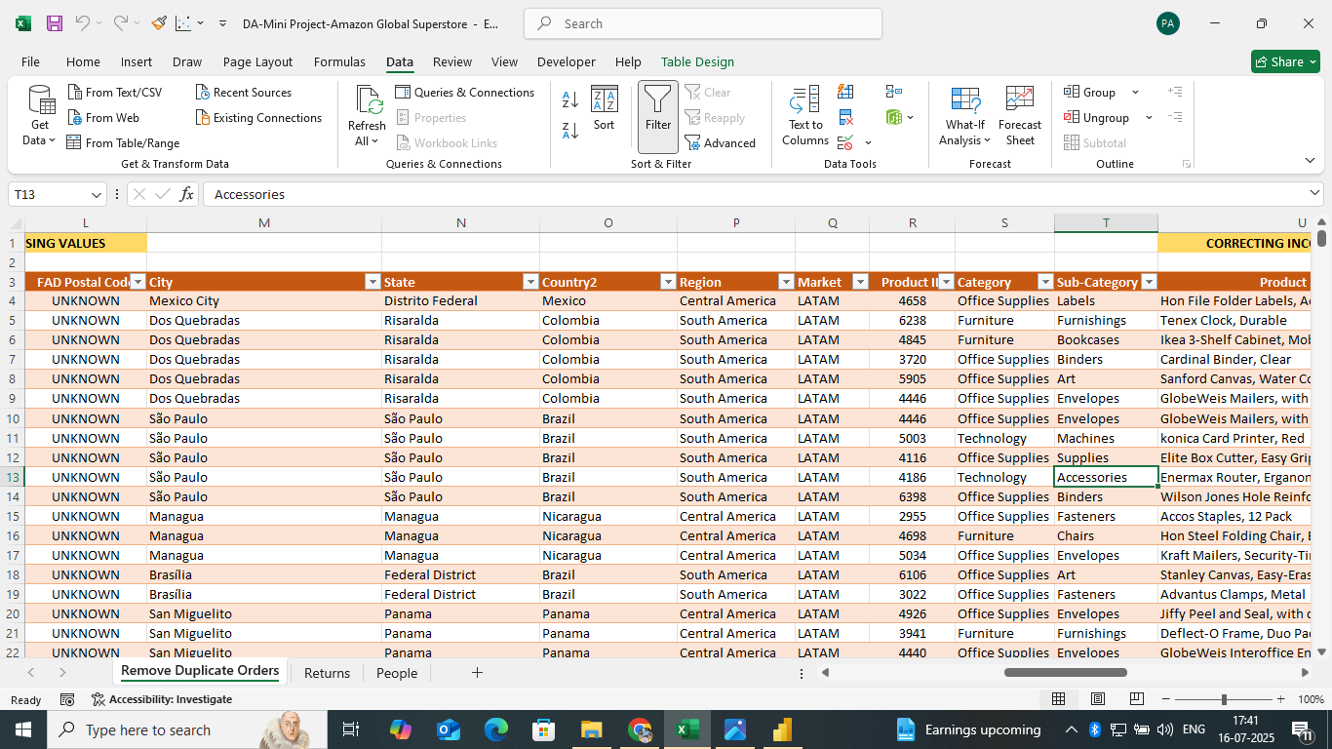

**Data Cleaning and Transformation:**

**Handling Missing Values:**

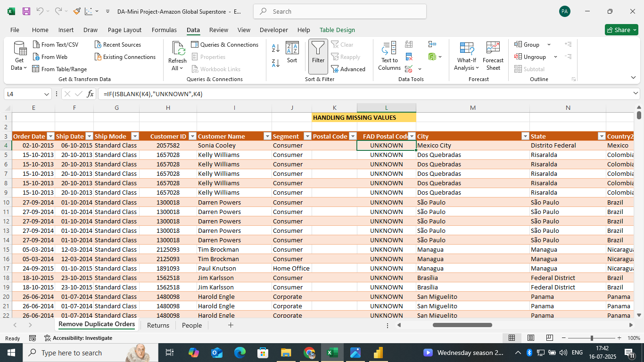

**Splitting and Merging using Delimiter:**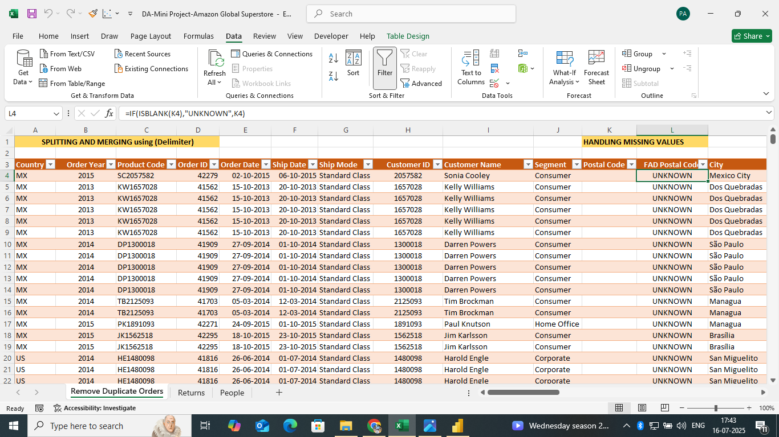

**Correcting Inconsistent Data:**

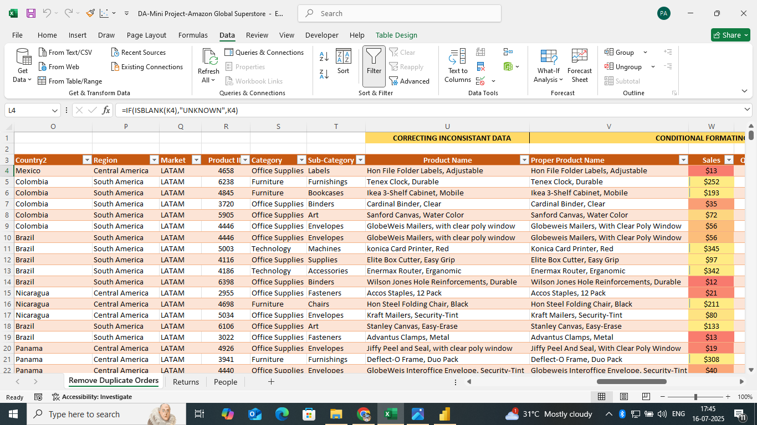

**Conditional Formating:**

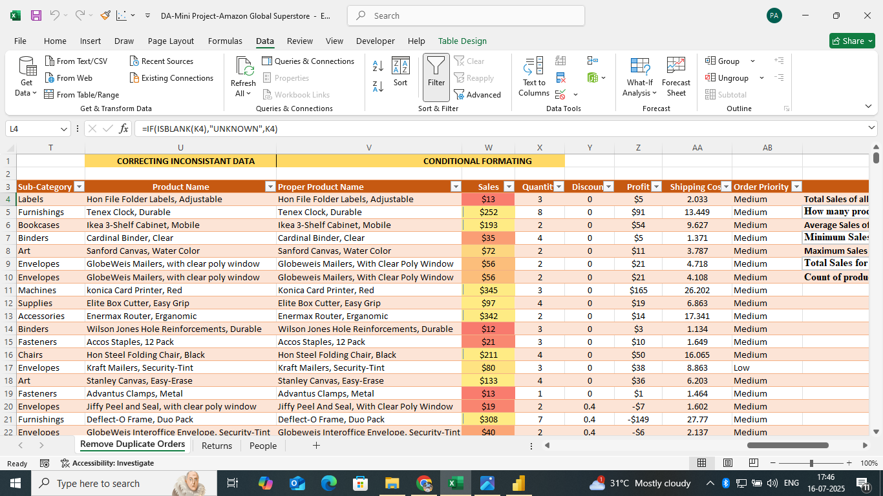

**POWER QUERY USING POWER BI:**

**Custom Column Profit Margin:**

| **Total Sales of all product (SUM)** | **$1,26,42,502** |
| --- | --- |
| **How many products (COUNT)** | **51290** |
| **Average Sales of the product (AVERAGE)** | **$246.49** |
| **Minimum Sales of all product** | **$0.44** |
| **Maximum Sales of all product** | **$22,638.48** |
| **Total Sales for product in using category Office Suplies (SUMIF)** | **3787492.513** |
| **Count of product with a Sales less than $200 using (COUNTIF)** | **36065** |

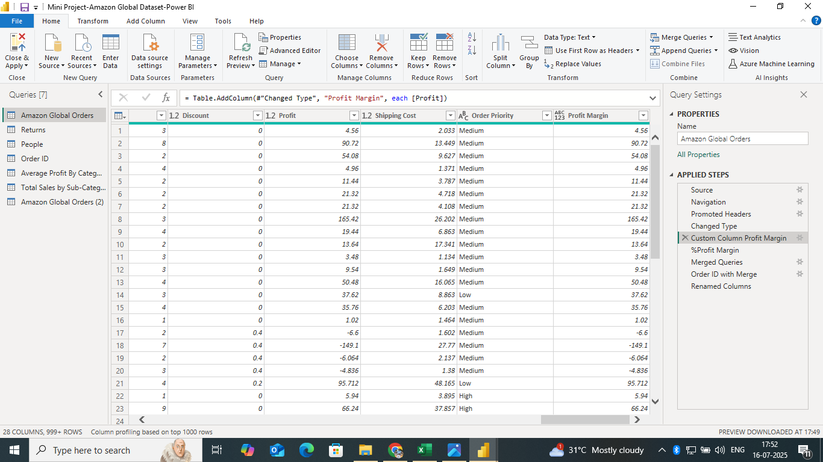

**Profit Margin with Percentage:**

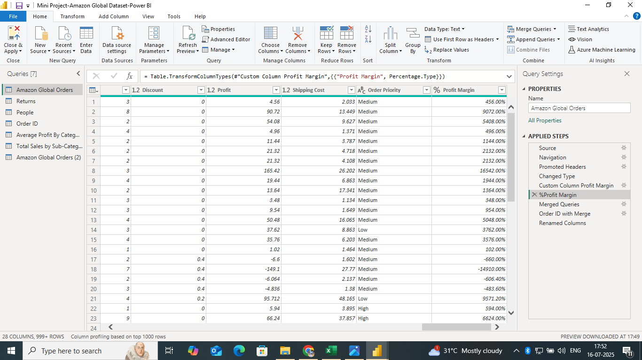

**Merge Queries using Order ID and Renamed Column:**

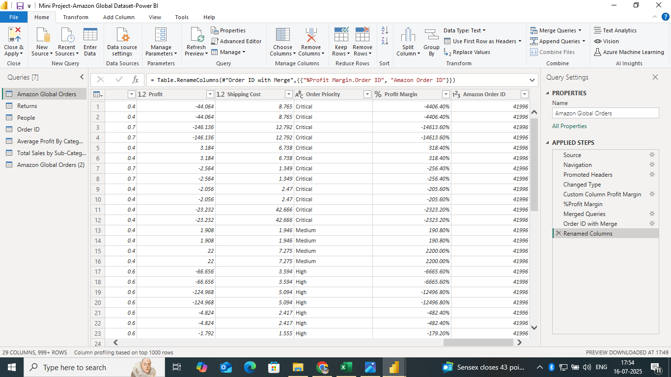

**Sorting and Filtering Rows in INDIA:**

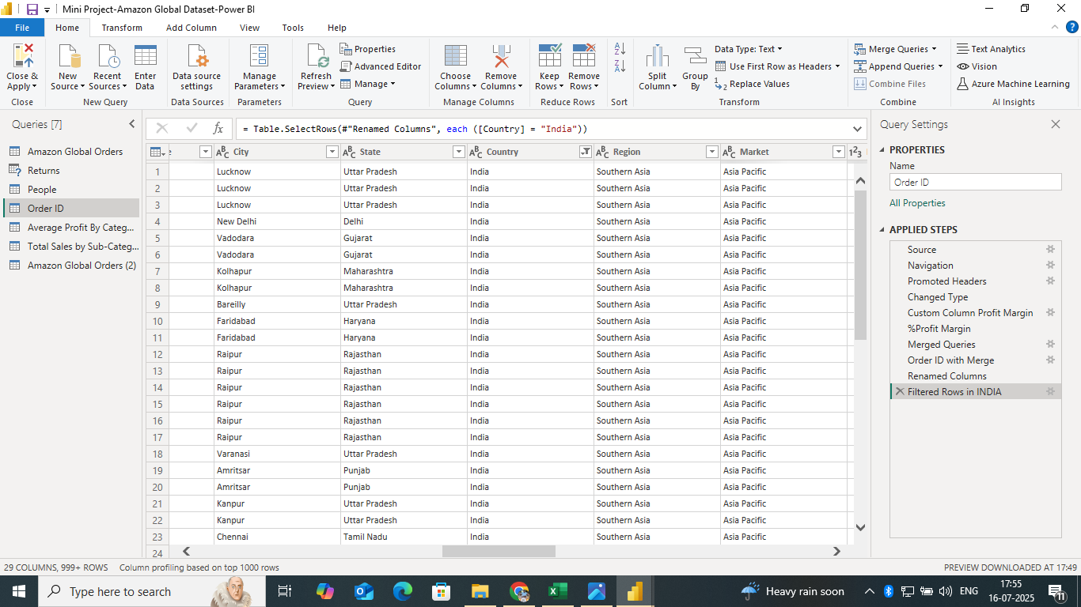

**Average Profit by Category:**

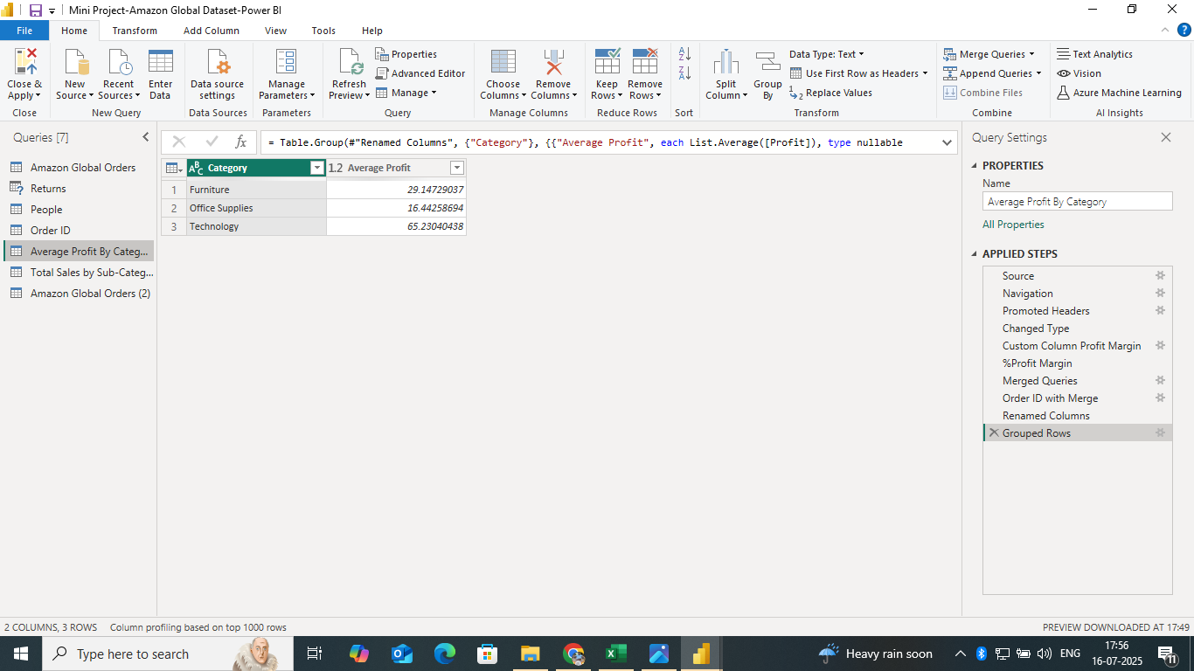

**Total Sales by Sub-Subcategory:**

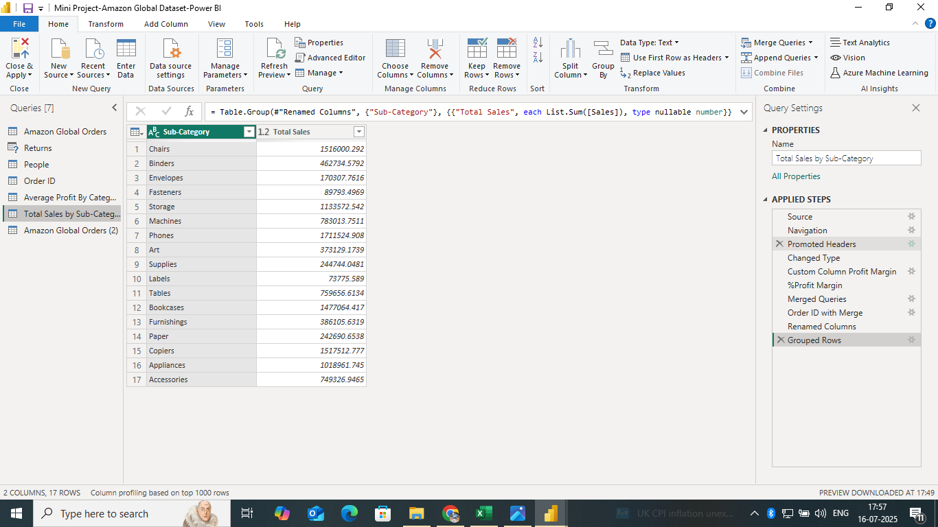

**Month of Sales by Order Date:**

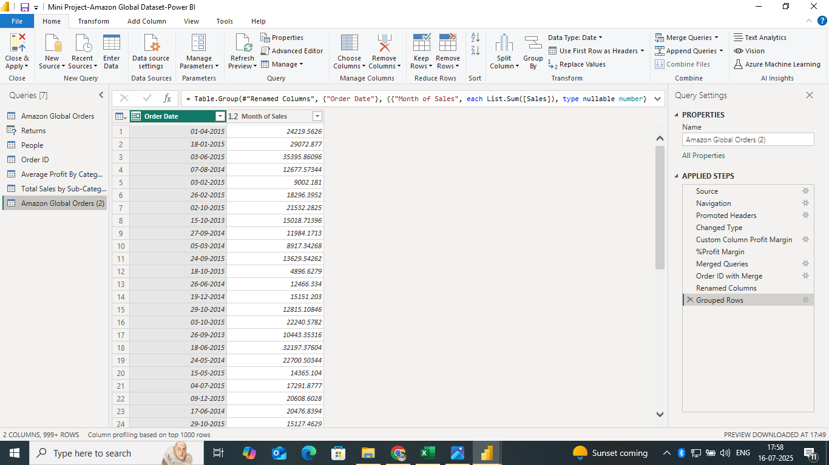

**POWER BI**

**DATA VISUALIZATION**

**Cards (9):**

**Total Units:**

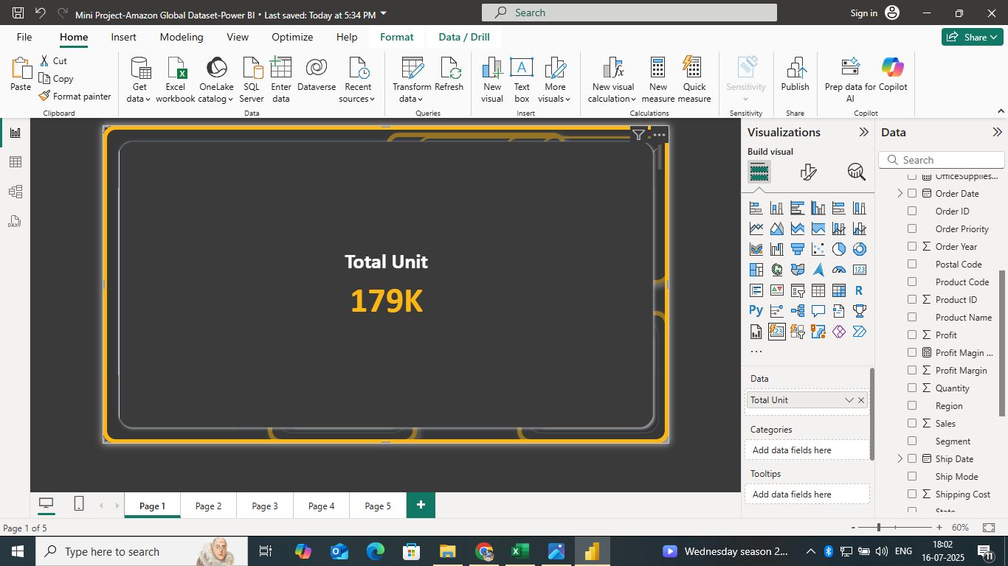

**Profit Margin:**

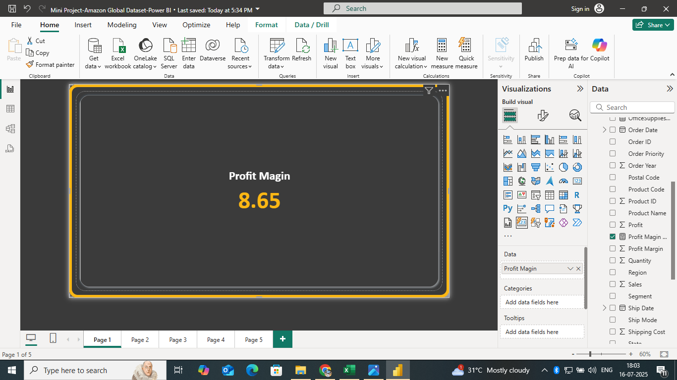

**Total Sales:**

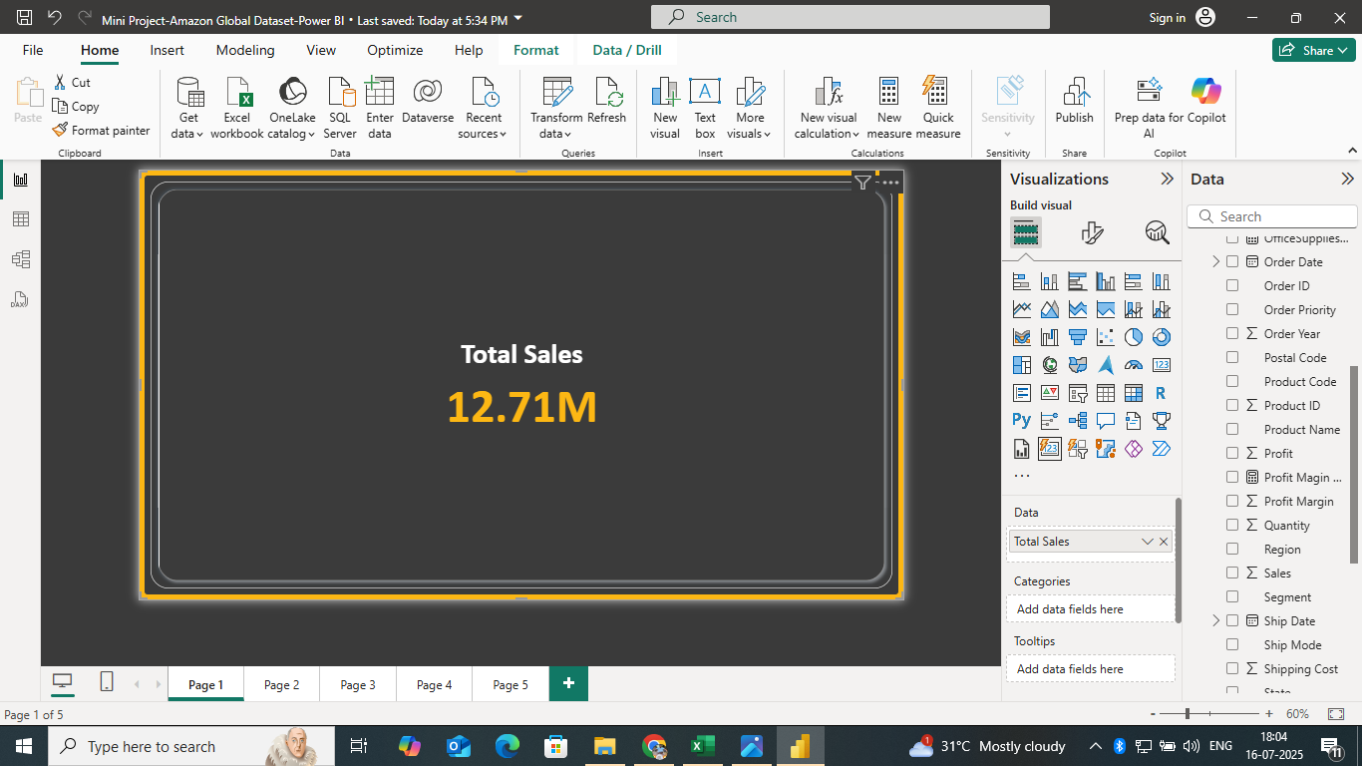

**Total Profit:**

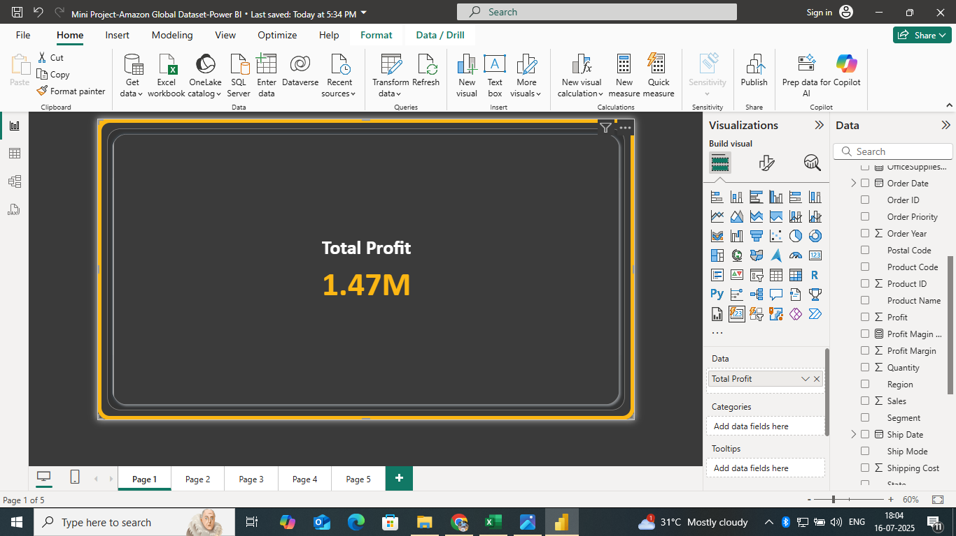

**Order Year:**

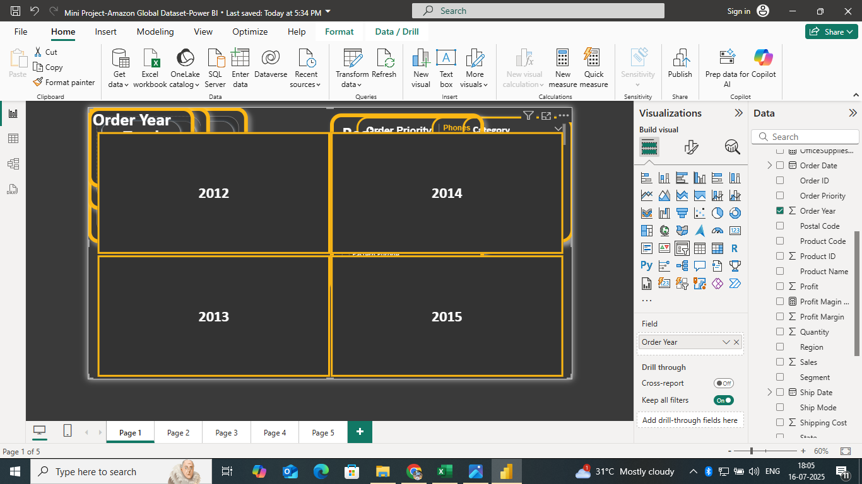

**Order Priority:**

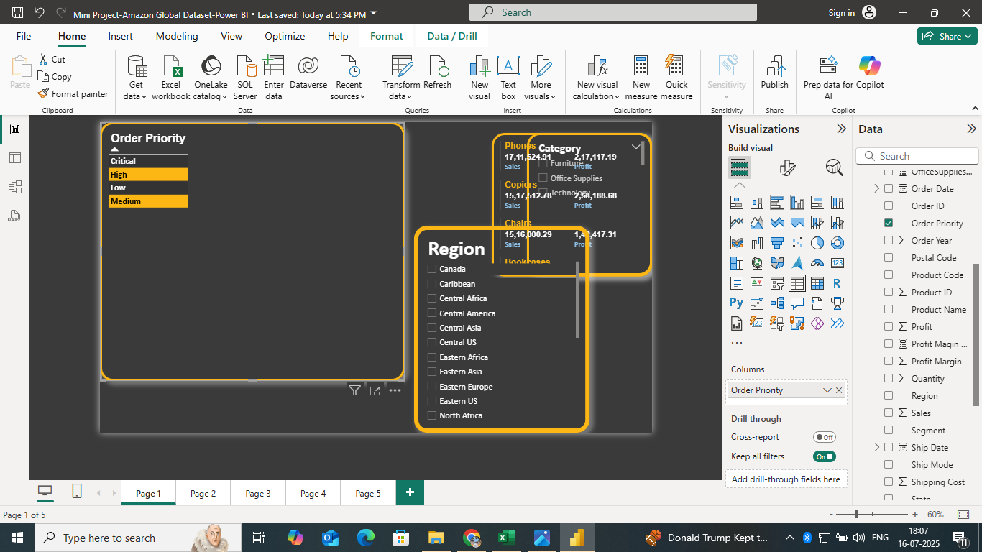

**Region, Sales Item, Category:**

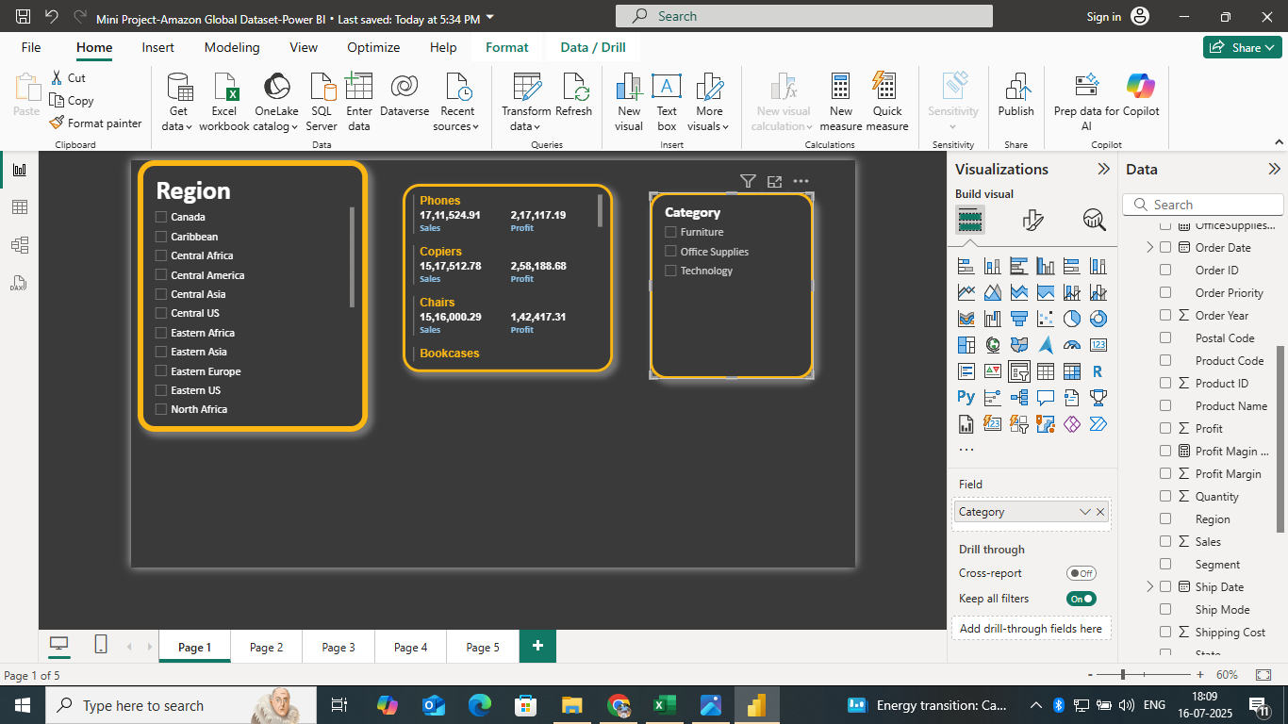

**Month of sales by Year and Product Name by Sub category vizuals:**

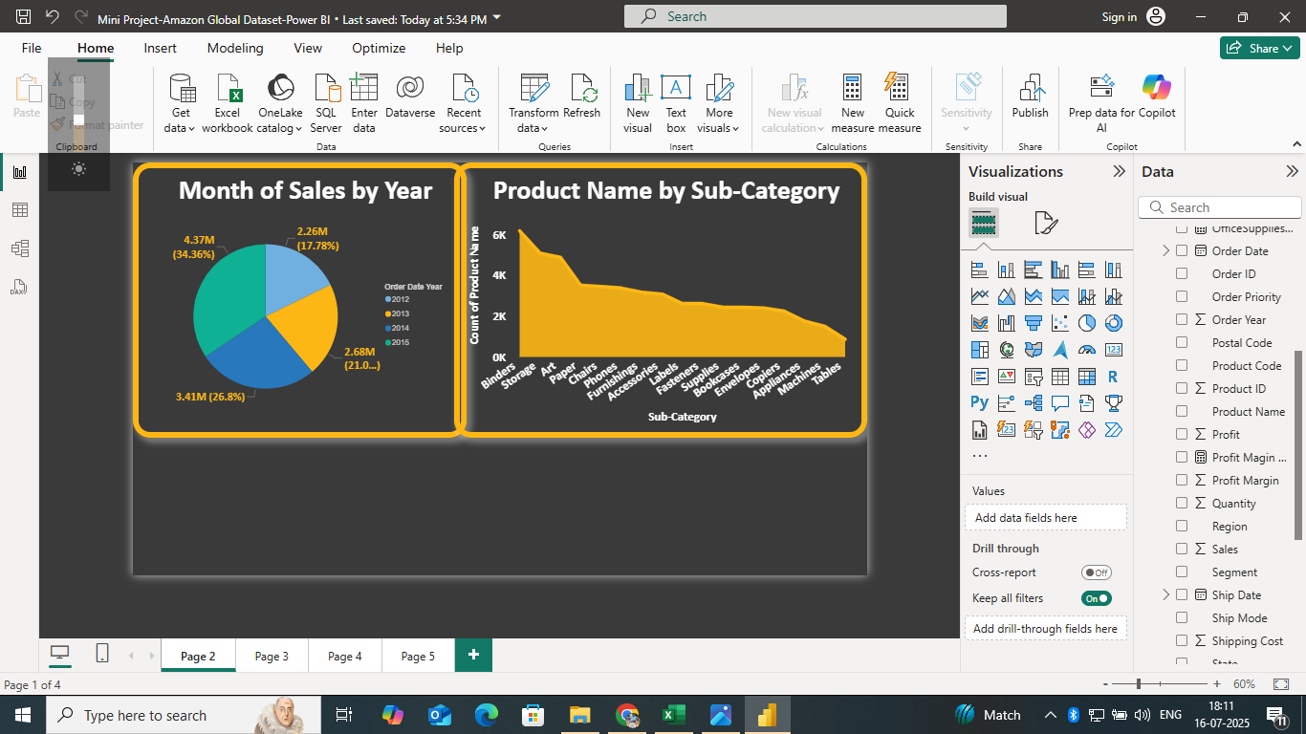

**Profit by Customer Name by Order Priority:**

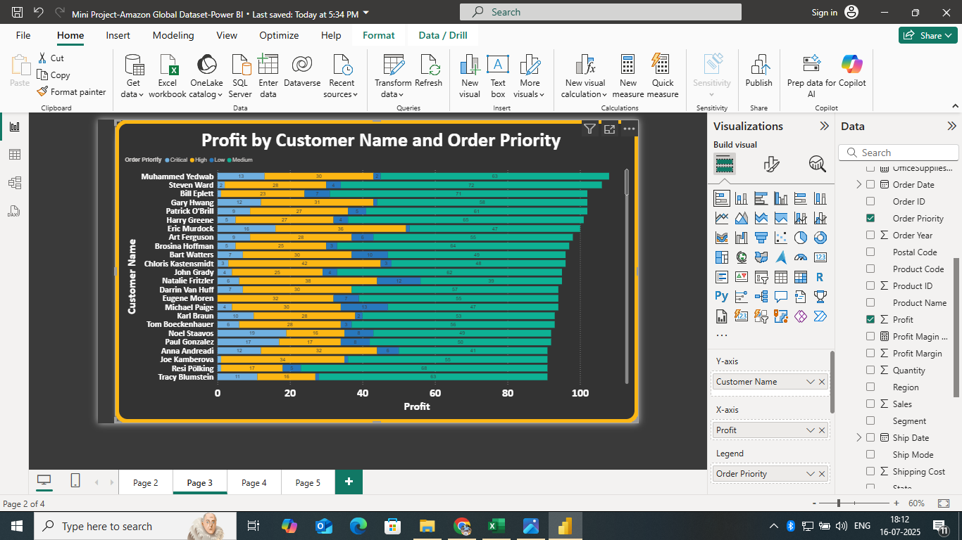

**Sales by Region:**

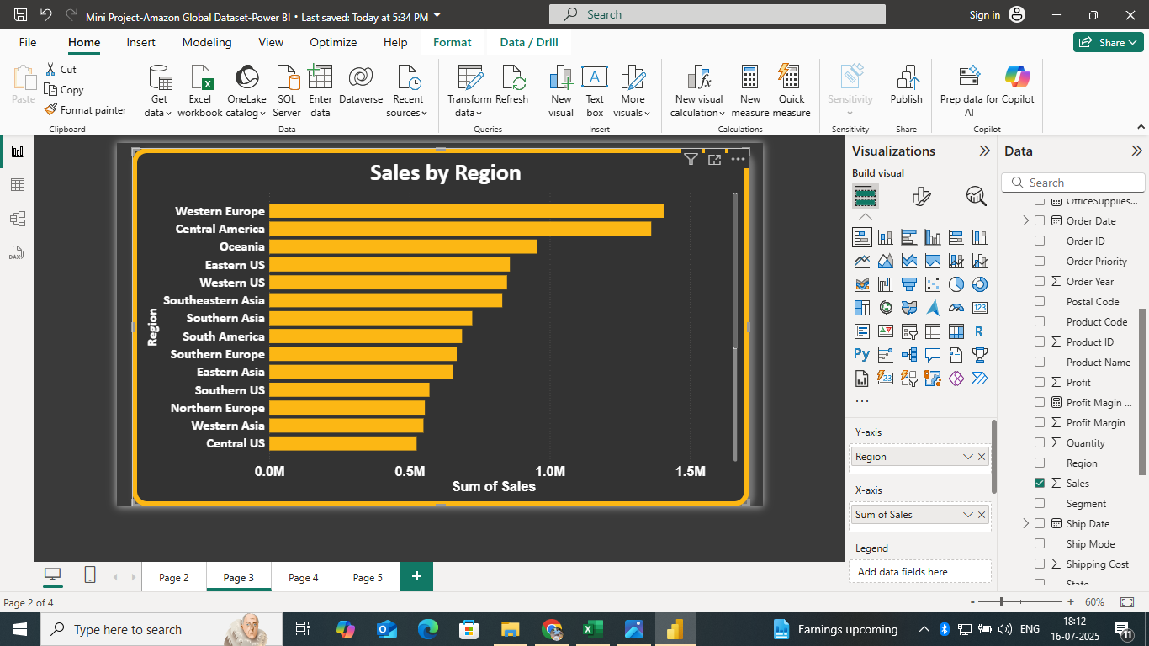

**Sales by Category:**

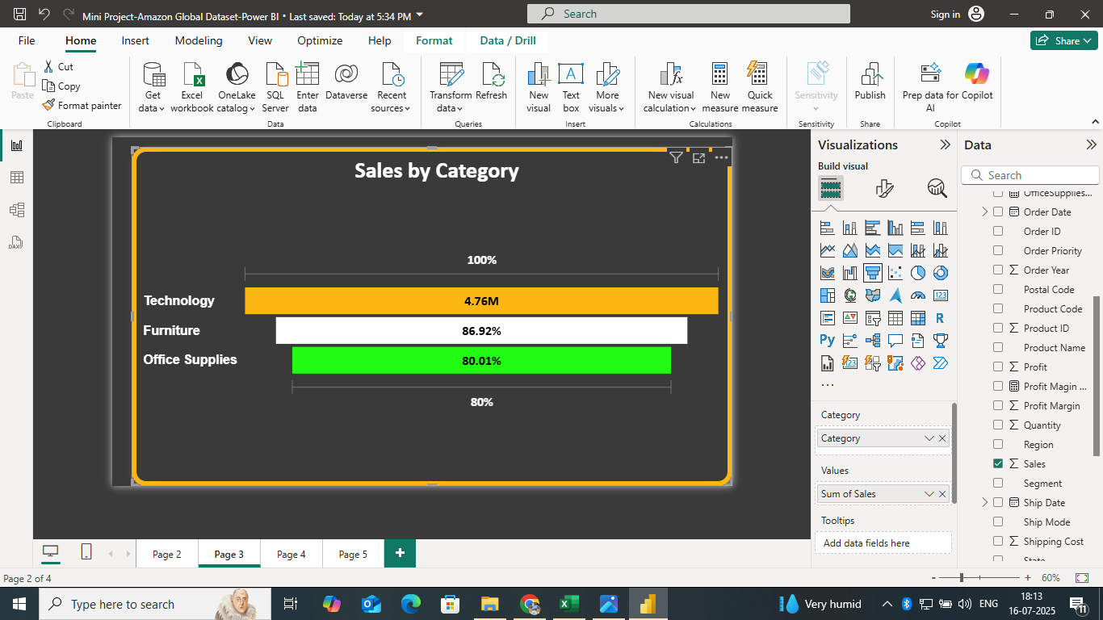

**Region and Sales:**

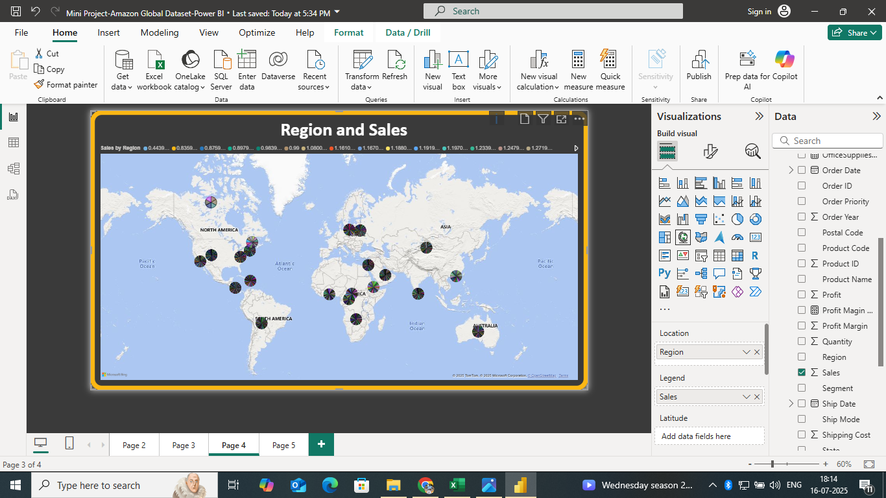

**DASHBOARD**

**AMAZON GLOBAL SALES**

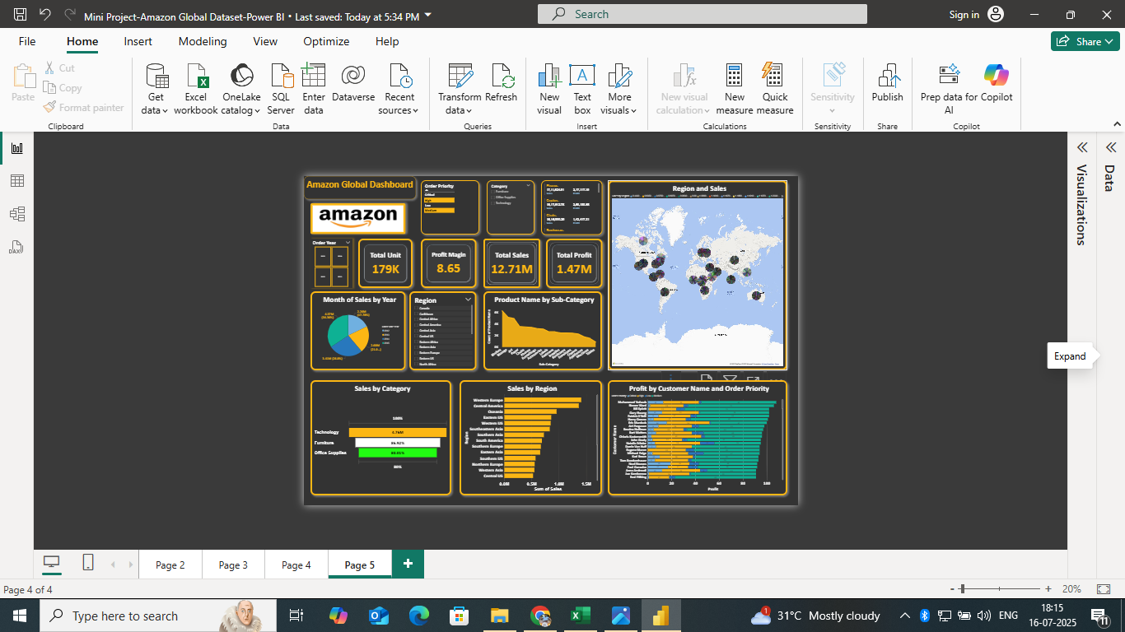

**THANK YOU**